Research (cell biology)

Our main research focus is on genotype to phenotype correlation, studying the pathogenesis of various neurodegenerative disorders like Spinocerebellar ataxias (SCAs), FRDA, and finding their therapeutic targets.

In India, it is quite challenging to get post-mortem autopsy tissues of the brain of the patient suffering from neurological disorders. In our lab, we generate Lymphoblastoid cell lines (LCLs) from peripheral blood mononuclear cells (PBMCs) patients. Also, to study the specific brain pathologies in these diseases we develop Induced pluripotent stem cells (iPSCs) from LCLs and further differentiate these iPSCs to Neurons, which we hope recapitulates the environment existing in the patient nerve cells. Thus, it exists as a good disease model that helps us in studying specific molecular perturbations.

Currently, we have more than 40 cellular models of different patients, our future goal is to include more and more diseases in our stem cell repository and elucidate their pathogenesis for therapeutic interventions.

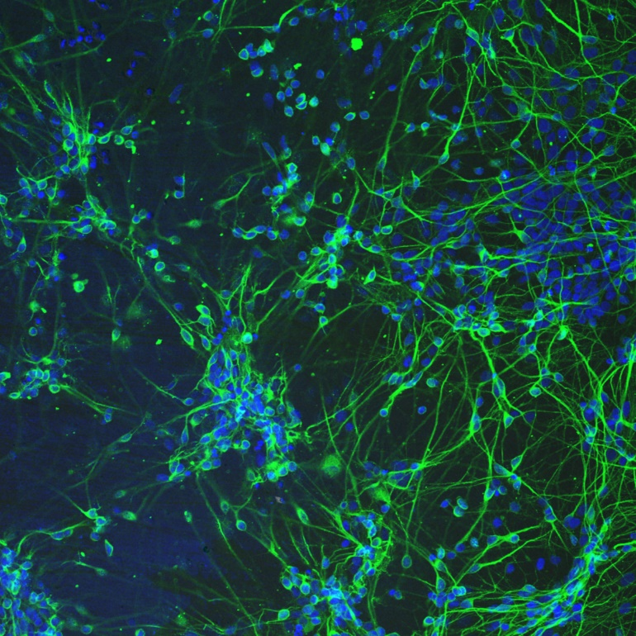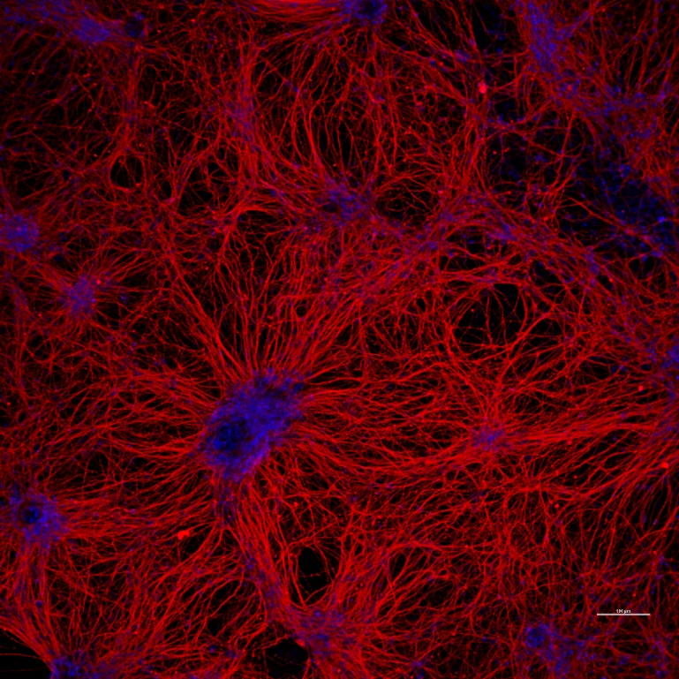

Pan neurons differentiated from Neural Stem cells derived from iPSCs of SCA-12 patient- Tuj1 (Red), MAP2 (Green), DAPI (blue).

Group members

Ishtaq ahmed, Nishu tyagi, Manish kumar, Saruchi Wadhwa, Sana Zehra, Asangla kamai

Publications:-

1. Erwin, G. S., Grieshop, M. P., Ali, A., Qi, J., Lawlor, M., Kumar, D., Ahmad, I., McNally, A., Teider, N., Worringer, K., Sivasankaran, R., Syed, D. N., Eguchi, A., Ashraf, M., Jeffery, J., Xu, M., Park, P., Mukhtar, H., Srivastava, A. K., Faruq, M., … Ansari, A. Z. (2017). Synthetic transcription elongation factors license transcription across repressive chromatin. *Science (New York, N.Y.)*, *358*(6370), 1617–1622. <https://doi.org/10.1126/science.aan6414>
2. Kumar D, Hussain A, Srivastava AK, Mukerji M, Mukherjee O, Faruq M. Generation of three spinocerebellar ataxia type-12 patients derived induced pluripotent stem cell lines (IGIBi002-A, IGIBi003-A and IGIBi004-A). *Stem Cell Res*. 2018;31:216‐221. doi:10.1016/j.scr.2018.08.008.